**Requirement Gathering and Analysis Phase**

**Solution Architecture**

|  |  |
| --- | --- |
| Date | 06-07-2024 |
| Team ID | SWTID1720074953 |
| Project Name | SB Foods-Food Ordering App |
| Maximum Marks |  |

**Solution Architecture:**

SB Foods - Order on the Go:

SB Foods - Order on the Go Solution Architecture Diagram. Include sections for User Interface (web and mobile apps), Backend System (order, restaurant, courier management), Data Management (customer, restaurant, delivery data), Security and Privacy, Scalability and Performance

User Interface:

Web Application: Develop a user-friendly and responsive website that allows customers to browse restaurant menus, place orders, track their delivery status, and provide reviews and ratings.

Mobile Application: Create a dedicated mobile app for iOS and Android platforms, offering a seamless and convenient ordering experience, including features like location-based restaurant suggestions and one-click re-ordering.

Backend System:

Order Management: Implement a robust order management system that handles order placement, payment processing, and order routing to the respective restaurants. This system should integrate with payment gateways and provide real-time order status updates.

Restaurant Partnership: Establish partnerships with a diverse range of restaurants, food outlets, and cloud kitchens. Provide them with a separate portal to manage their menus, track orders, and maintain their availability and delivery radius.

Courier Management: Develop a courier management system that allows couriers to register, set their availability, and receive delivery requests. Implement algorithms (such as QMIX and IQL) to optimize courier routing and guide them to areas with high demand, improving efficiency and income.

Data Management:

Customer Data: Store and manage customer data securely, including registration details, order history, preferences, and payment information. Implement data protection measures to ensure user privacy.

Restaurant Data: Maintain a database of restaurant partners, including their menus, pricing, operating hours, and delivery coverage areas. Regularly update this information to provide accurate options for customers.

Delivery Data: Collect and analyze delivery data, including delivery times, courier performance, and customer feedback, to improve the efficiency of the delivery process and enhance the overall customer experience.

**Solution Architecture Diagram:**

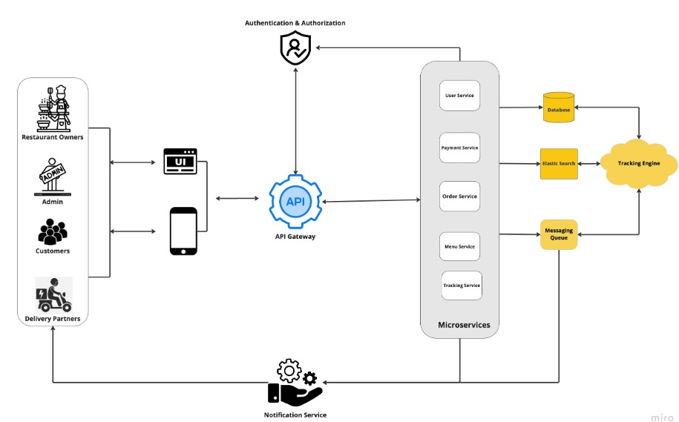

Figure : Food Delivering system